**Hello World**

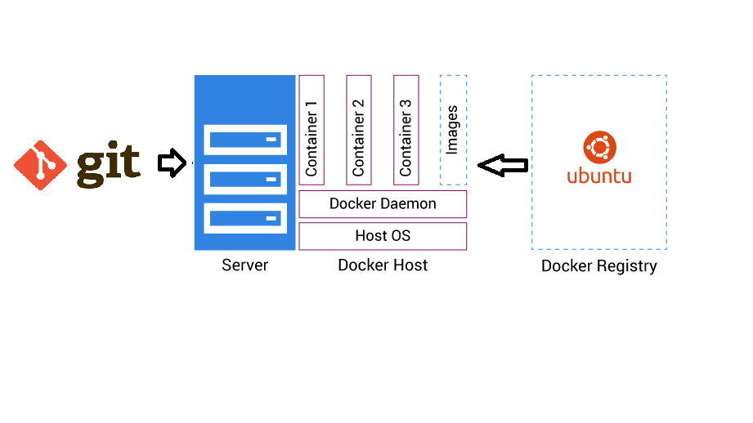

**Design**:

Hello world application is developed in Java with Rest API’s.

Helloworld-0.0.1-SNAPSHOT.jar is generated using maven build tool.

A docker image is created to host the application and the same is pushed into docker hub registry. Using the image, the application is hosted in 3 containers to make it highly available. If any container is out of service, the docker service will create another container automatically. These conatiners can be scaled as needed.

The application jar file and software installation scripts are placed in GIT repoistory.

**Deployment steps:**

1. Clone the git repository from

<https://github.com/kiran-hometask/birthday.git> on any linux machine in the /home/ansible path.

1. Run ansible_install.sh with ansible user if user is available, else create an user and then execute ansible_install.sh. This will install all the required softwares and creates 3 containers as a service.

**Testing:**

Open the link below in a web browser.

[http://localhost:8080/swagger-ui.html#/person-controller](https://urldefense.proofpoint.com/v2/url?u=http-3A__localhost-3A8080_swagger-2Dui.html-23_person-2Dcontroller&d=DwMFaQ&c=ilBQI1lupc9Y65XwNblLtw&r=qgLHP1OYSTnNPGRhzWRdd48CpZSEDcW06wuwj_SnQRU&m=IdIZJh40B02rEekOrWbrFGVhexy5bLyfu7DOmEUKKl0&s=GbyKz-byqtB5vVNszb_z9dH4j42sP4YnWLhmevi0_Aw&e=)

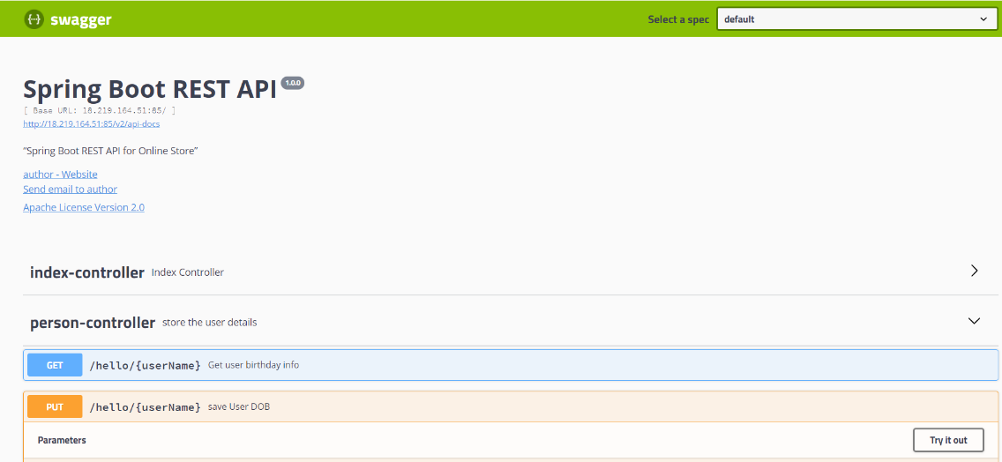

**Test Scenario 1:**

1. Click on Try it out as highlighted in the image below for a PUT request.

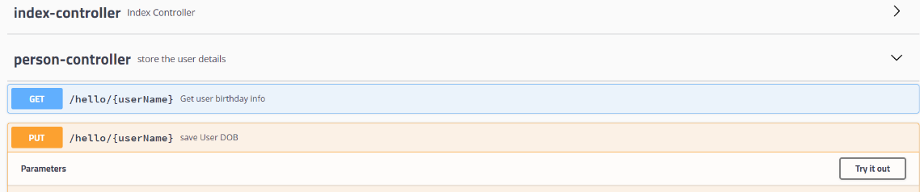

1. Add data to add DOB and name as highlighted

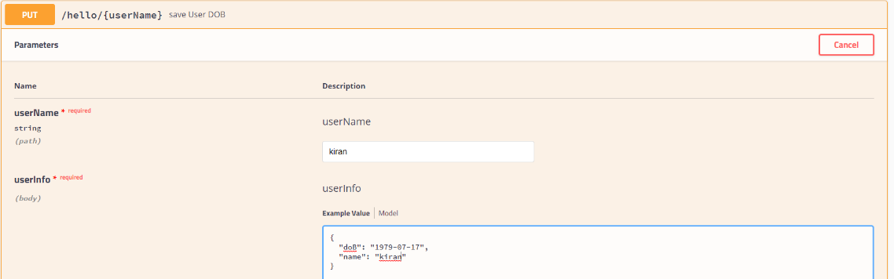

1. Click on Execute as highlighted below.

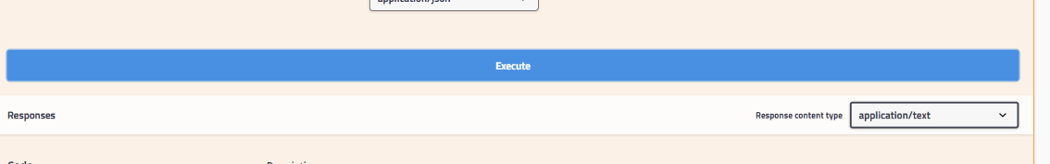

1. Find the response code as below for sucessful put request.

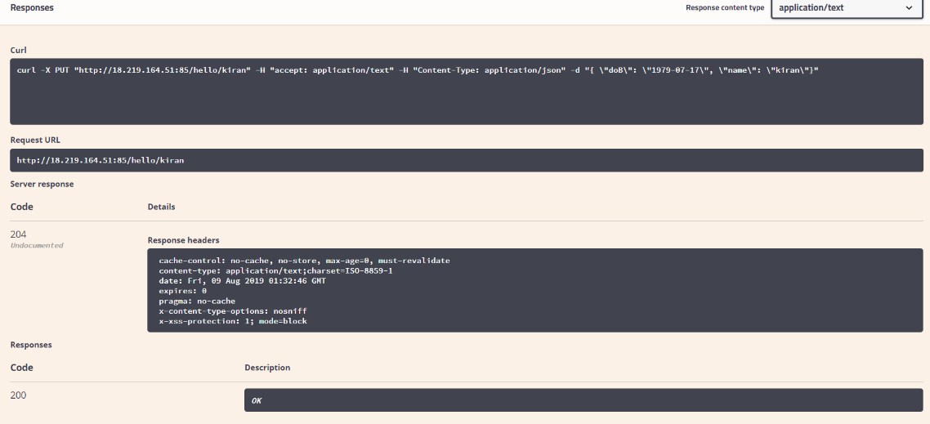

1. Click on Try it out as highlighted to perform GET request

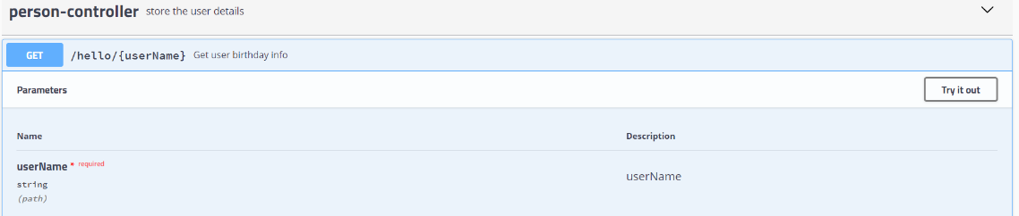

1. Enter the username kiran

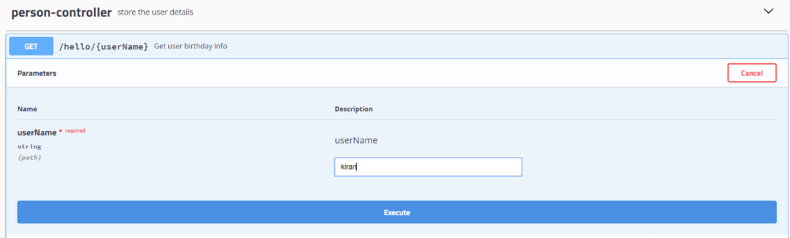

1. Find the response as below, which shows the username’s birthday is in N days

